A Neuromechanical Model for Examining Viscoelastic Properties and Scaling Effects on Locomotion in a Rat Hindlimb

Fletcher Young

Abstract

Mechanical models are useful for understanding the impact of individual components that are intractable for experimental process. This work presents a model for understanding how the viscoelastic effects of a muscular system impact the control strategies of that system. First, this model has been validated through a number of benchmark processes. Second, this model is tested under a number of different viscoelastic situations. Finally, this model will be used to explore how control systems are implemented to leverage viscoelastic properties in order to take advantage of the available space.

To better understand the how the nervous system utilizes coordinates a complex viscoelastic system, I will:

**Aim 1 - Create and validate a kinematic model of a rat hindlimb with a complete viscoelastic musculature.** To investigate the coordination of a viscoelastic system, I have developed a model of a rat hindlimb. This model has been validated against two existing rodent models by comparing muscle moment arms. Viscoelastic muscle parameters have been derived from experimental data from hanging leg experiments. Additionally, novel tools for developing neuromechanical systems in Animatlab have been created to aid this work.

**Aim 2 – Investigate muscle activation strategies for hindlimb motion for situations of viscoelastic control.** Muscle activation strategies can be calculated for different limb actions. We will modify the viscoelastic muscle properties and examine how the muscle activations accommodate the different configurations.

**Aim 3 – We will test the**

Project Motivation

The cyclical nature of form influencing function and vice versa is a basic principle that underlies the development of all living systems. Evolution encourages the development of behavior and physical characteristics necessary for survival in the surrounding environment. As such, environmental constraints have a direct influence on the development of characteristics best suited for the survival of future generations. Body structures, developed to manipulate the environment, determine the capabilities of the animal to manipulate the world. The structure of the nervous system determines how individual parts of the body are controlled. By analyzing the interconnected nature of form and function, it may be possible to develop novel control systems better suited for environmental manipulation.

Though their activity is often analyzed independently, an animal’s nervous and body system develop simultaneously within an ever-present external environment (Chiel and Beer 1997; Chiel et al. 2009). The nervous system compartmentalizes neural processes relevant to local body systems. Passive properties of the body determine the system dynamics, acting as a transfer function from neural activation to environmental manipulation. Finally, the state of the environment dictates how the nervous and body system manipulate the world and, over time, can dramatically alter an animal’s physiology as it carries out adaptive behavior (Chiel, Beer, and Sterling 1988; Pfeifer, Lungarella, and Iida 2007).

Models of animal systems recreate the activity of these interconnected subsystems to better understand the morphology that drives them (Nishikawa et al. 2007). Contemporary models, however, often analyze only one part of a whole animal, reducing the complex systems into computationally manageable parts. While the information gained from these models can be useful for specific applications, they fail to capture the complex interconnections between the different subsystems that are fundamental to understanding the complete pathway from neural activation to environmental manipulation. These models, which serve as the basis for both biological research and robotic design, are most valuable when they provide a holistic interpretation of the animal and the environment it inhabits.

Simulating a system is a useful alternative to biological experimentation that allows researchers to noninvasively test hypotheses regarding unknown neural components. Current simulation tools offer a variety of features for designing neural and physical components of neuromechanical systems. Some environments focus on the creation of neural systems while others focus on kinematic systems in physics environments. Few simulation tools allow for the development of both systems simultaneously, a feature that is critical for the creation of true-to-life neuromechanical systems.

Animals are better suited than robots to address environmental hazards during walking, suggesting that a biologically-inspired control system could be an effective foundation for robotic control (Beer et al. 1997). In recent years, a growing number of robots have incorporate biological principles into their design in an effort to emulate animal behavior (Webster-Wood et al. 2017; Hunt, Szczecinski, and Quinn 2017; Sharbafi et al. 2016; Schrade et al. 2018; Lakatos et al. 2016). In particular, robots have incorporated muscle-like actuators (Chang et al. 2017) and control systems modeled after spinal cord circuits to coordinate locomotion in legged systems (Beer et al. 1997). However, emulating legged locomotion in real-world robotics is difficult with available actuators and traditional robotic control systems. There is an opportunity for the simultaneous advancement of engineering fabrication and biological investigation through the implementation of novel robotic design practices.

This work first presents the creation of a neuromechanical model with a neural and physical system in simulation. Through the development of this model, the interconnected nature of nervous and body systems is analyzed within the context of neuromechanical simulation. This work culminates in the proposal of a novel simulation environment meant to fill a gap in the state of the art: a simulation environment for the simultaneous development of neural and physical systems that takes into account scaling effects and spatial configuration of neural systems.

# Aim 1 - Create and validate a kinematic model of a rat hindlimb with a complete musculature.

## Motivation

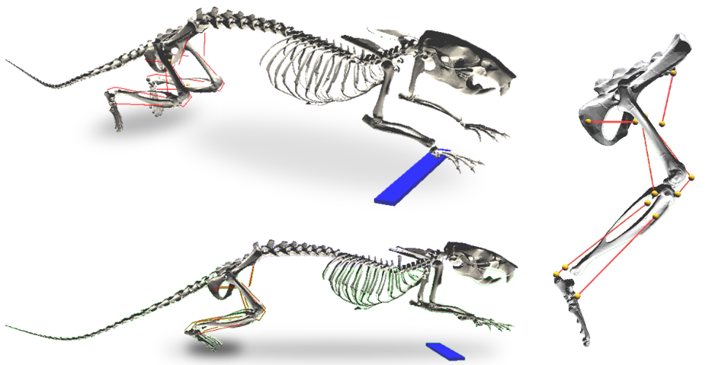

**Figure 1** Hunt's rat model. The torso and upper limbs are held stationary above the ground as the hindlimb muscles coordinate locomotion. Red lines indicate muscle paths and yellow markers represent muscle attachment points.

An accurate kinematic system is necessary to develop plausible kinetic measurements, such as joint torque, muscle forces, and ground reaction forces. This work builds off of a neuromechanical model developed by Dr. Alexander Hunt in completion of a doctoral thesis (Hunt et al. 2014; 2015; Hunt 2016). Hunt's rat model, shown in Figure 1, included a simulated nervous system that coordinated hindlimb muscles to emulate locomotion in a nominal environment using discrete subunits known as central pattern generators (CPGs) (Beer, Chiel, and Gallagher 1999; McCrea and Rybak 2008). This presented a novel method of tuning neural parameters for hypothetical neural feedback systems to induce self-supported walking. In order to analyze the organization of the nervous system that coordinates the over actuated hindlimb, it is necessary to expand the musculature of Hunt’s model.

Muscle Attachment Points

Muscle paths are simulated by affixing muscle attachment points onto a 3D rat skeleton. These attachment point represent both points where muscle attaches to the bones, but also acts as via points to approximate curved muscle paths. Muscle contraction is coordinated to move bones relative to each other and approximate locomotion.

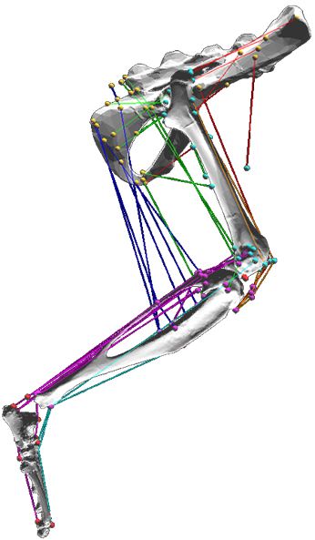

**Fig. 2.** A neuromechanical model of the rat hindlimb developed in Animatlab with thirty-eight muscles. Colored lines represent muscle lines of action, muscle attachments are shown as small spheres that are stationary within individual bone reference frames. Colors denote general muscle grouping for visual clarity but do not have a functional significance. Muscle attachment points not directly on a bone surface represent soft tissue attachment.

I developed muscle lines of action based on anatomical drawings and descriptions from E.C. Greene’s 1955 publication Anatomy of the Rat (Greene 1955). This work provides detailed descriptions of muscle attachment points relative to bone structures, neighboring muscles, and tendons as well as muscle paths around bones. Due to limitations in the simulation software, it is only possible to represent muscles as lines of action with origin, insertion, and via points that are fixed within local reference frames affixed to the bones. For muscles that attach to bones along a line of attachment (such as the gluteus maximus running along the dorsal border of the ilium), a single attachment point was placed approximately halfway along the line of attachment.

**Publication**

1. Young, F., Hunt, A. J. & Quinn, R. D. A Neuromechanical Rat Model with a Complete Set of Hind Limb Muscles. in Biomimetic and Biohybrid Systems 527–537 (Springer, 2018).

## Kinematic Validation through Dynamic Muscle Moment Arm Profiles

Moment arms are a representation of the mechanical advantage a muscle has about a joint (Visser et al. 1990; S. W. Lee et al. 2008; Williams et al. 2008; Yeo et al. 2011; Charles et al. 2016). Understanding the mechanical advantage of muscles is important for determining the appropriate force contributions the muscle can make throughout motion. Moment arm profiles (the length of a muscle’s moment arm about a single joint over its range of motion) are a useful metric whereby a model can be validated against existing hindlimb models.

Moment arm analysis is discussed in detail in a paper published in the Journal of Biomimetics (Young et al. 2019). This work first presents the methodology used to calculate moment arms in the model which is rooted in fundamental principles of vector mathematics. This is in contrast to some contemporary methods which employ automatic moment arm calculations that are built-in routines in modern software (such as OpenSim).

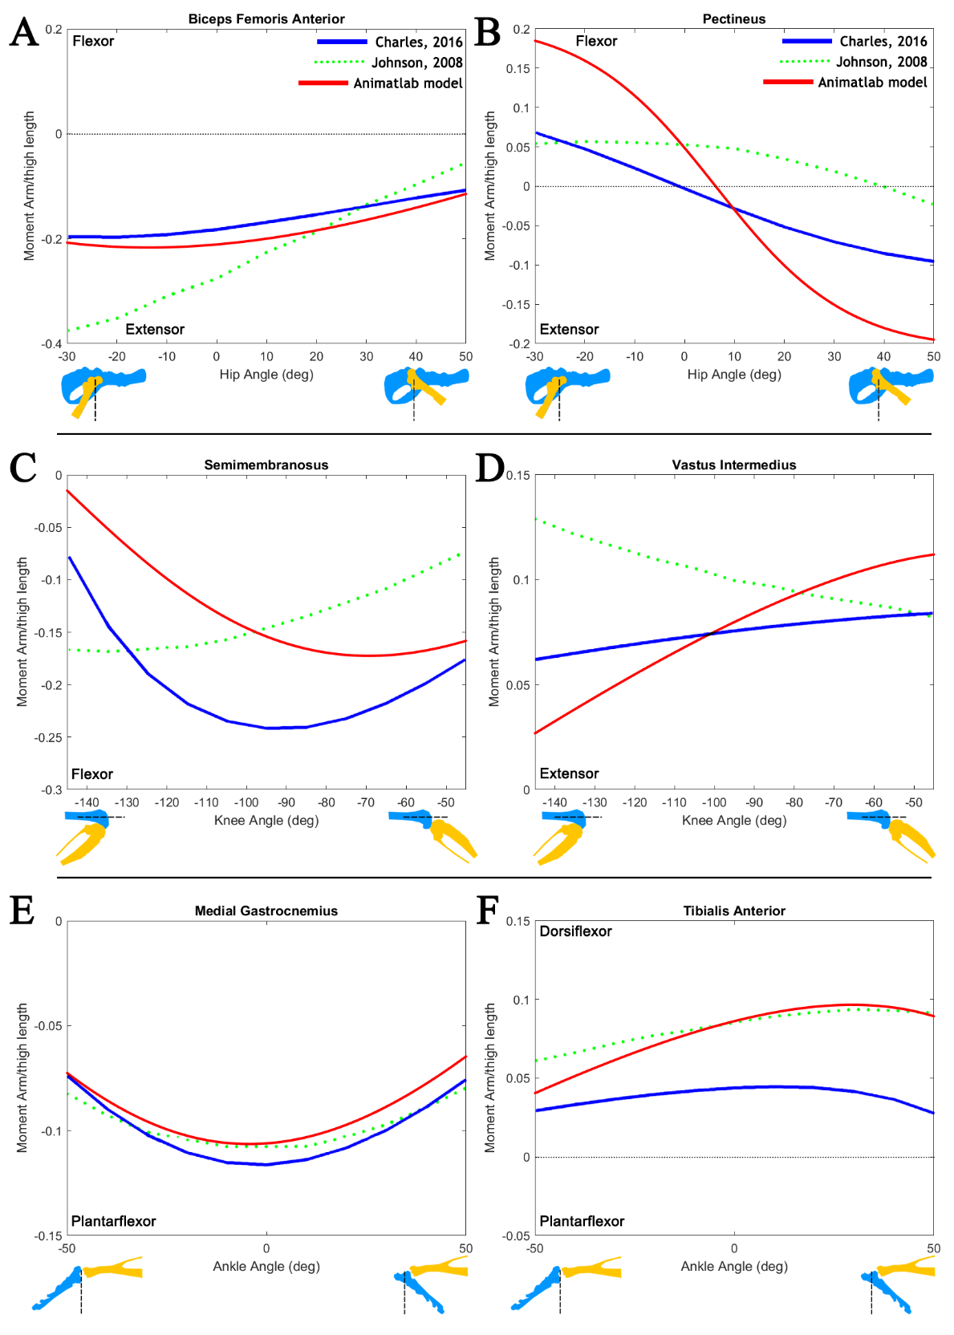

**Figure 3** Moment arm profiles for select muscles in comparison to two existing rodent models. Moment arm profiles show most similarities with the Charles mouse model. It is difficult to determine the cause of deviations from Johnson’s model since the method used to calculate them is not well defined. Some trends in the mechanical advantage (e.g. pectineus) make more sense for Charles than Johnson.

A routine was developed in MATLAB for calculating muscle moment arm lengths for an arbitrary limb configuration. By “driving” the limb in Animatlab with motors placed at the joints, it is possible to determine muscle moment profiles for any desired limb trajectory. Moment arm profiles for select muscles were calculated for the full range of motion of individual joints. As seen in Figure 3, these profiles showed comparable magnitude, range, and shape to those found in a rat and mouse model (Charles et al. 2016; Johnson et al. 2011).

In addition to calculating moment arm profiles, a sensitivity analysis was conducted to examine the impact of muscle attachment point placement on sagittal plane moment arm profiles. The sensitivity analysis showed that moment arm profiles were robust and maintained their shape across limb configurations even when muscle attachments were shifted independently.

## **Publications**

1. Young, F., Rode, C., Hunt, A. & Quinn, R. Analyzing Moment Arm Profiles in a Full-Muscle Rat Hindlimb Model. Biomimetics 4, 10 (2019).

Model Validation through Viscoelastic Parameters Selection

Physiological parameters (muscle mass, maximum tension, etc.) for rat hindlimb muscles have been described by Johnson et al. (Johnson et al. 2011) and Eng et al. (Eng et al. 2008). Initial efforts we made to directly implement all parameters from the literature, including optimal muscle lengths, but fitting these values to the model could not converge to stable solutions. Instead, the tension equation from the linear Hill model (Hill Archibald Vivian 1938) used in Animatlab has been decomposed into two primary sections: the viscoelastic properties and two length-activation curves. I formulate these properties separately and, as such, will discuss their calculations independently.

Viscoelastic Properties (Ks, Kp, B)

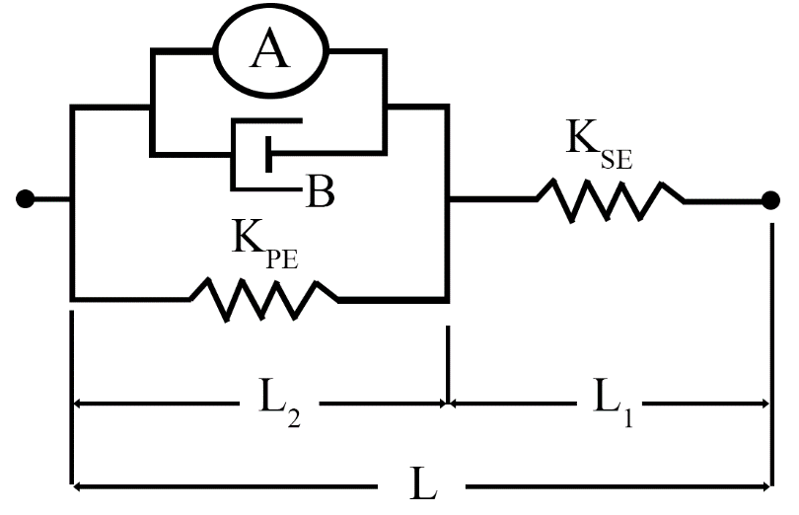

**Figure 4** The linear Hill muscle model implemented in Animatlab. The force generating component, A, is composed of a length-tension and stimulus-tension term. Circular ends represent muscle attachment points connected to bone meshes.

Animatlab implements a two-compartment Hill muscle model (Figure 4) with an elastic spring element (Kse) representing connective tissue in parallel with a damping element (B), parallel spring element (Kpe), and a contractile element. The nonlinear tension of the Hill model has been formalized (Shadmehr and Arbib 1992),

,

where T is muscle tension,  is serial element stiffness,  is parallel element stiffness, L is muscle length, B is the muscle damping factor,  is a dimensionless tension-length percentage, and  is muscle activation in Newtons.

The viscoelastic properties of muscle are determined by fitting simulated joint motion to experimental hanging leg data. Skin marker data has been gathered from our partners at Northwestern University in which a rat leg hangs freely and individual electrode stimulation is applied to different muscles. In Animatlab, I stimulate these same muscles and measure the joint motion. Through an optimization routine, I am able to reduce the sum squared difference of the joint angle waveforms by changing the viscoelastic properties.

Length-Activation Curves (Al, Am)

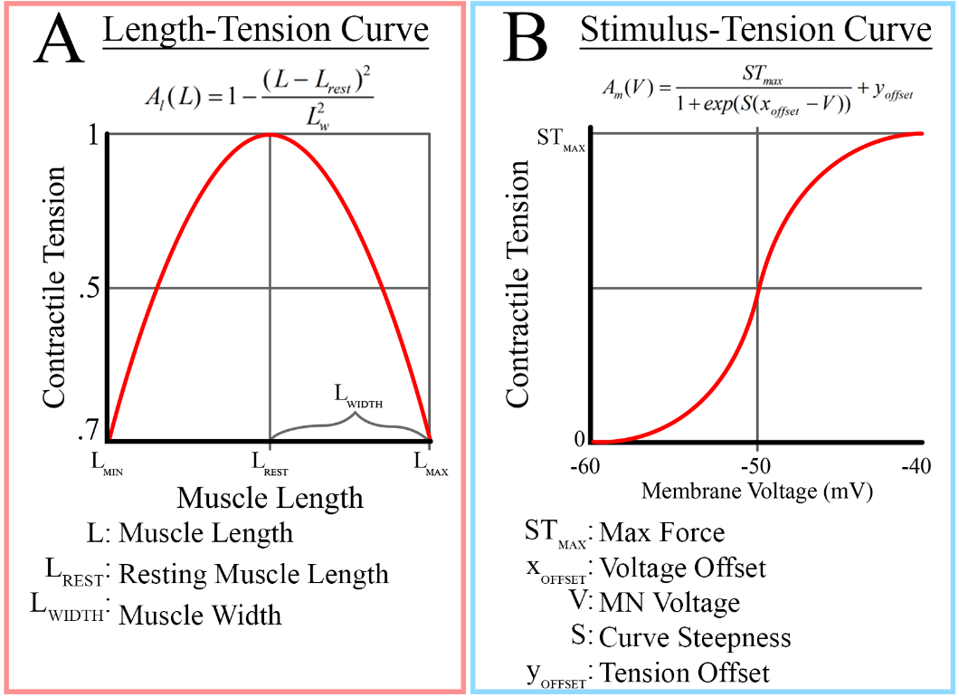

**Figure 5 A)** The length-tension curve relates the maximum attainable tension at an isometric length. **B)** The stimulus-tension curve relates the motorneuron activation to the tension in the muscle.

Two length-activation curves form the basis of force generating properties in the Hill model: the length-tension (LT) and the stimulus-tension (ST) relationships. In the muscle tension equation, these curves are represented by the terms Al and Am. The LT-curve relates a muscle’s force-generating capabilities at various isometric lengths while the ST-curve relates the membrane potential to force output.

The LT-curve (Figure 5B) relates the maximal tension generating capability of muscle at different lengths. Based on assumptions from Zajac (Zajac 1989), the muscle is capable of generating the maximum possible force at its resting potential. The resting length for muscles is determined by moving the leg through its full range of motion and finding the midpoint between its two extremes. The muscle width is set such that at the length extremes the muscle is capable of generating 70% of its maximum tension.

The ST-curve (Figure 5B) relates the motorneuron activation to muscle tension. No tension is generated at a resting potential of -60mV, while at full activation (-40mV) the muscle generates a maximal contractile force, STmax. STmax is set such that at steady state, the activation term is capable of generating the full value of the maximum tension. The steady state tension is a function of length and activation,

.

At resting length, the steady state tension becomes

.

In order to avoid turning the activation curve into a bang-bang system (i.e. making the curve so steep that it essentially becomes an on-off switch), the steepness and y-offset are set such that the activation output ranges from zero at -60mV and STmax at -40mV. For motorneuron activation to generate the maximum isometric tension at resting length, the maximum value of the activation (ST) curve must be

.

The resulting steepness for this range equates to 459.5 for all muscles and a y-offset of

.

Modifications of Muscle Model in Animatlab Source Code

While formulating tension profiles, it became apparent that the tension calculations in Animatlab contains a small error that made predicting muscle forces difficult. Two key restrictions in parameter selection have been identified and were discussed in a Living Machines publication (Young 2020).

Tension Deadzones

In Animatlab’s native muscle tension model, there are regions of length and activation where tension should be present but is not. The reason for this is a numerical error in the equation that determines the internal tension of muscle and is best represented visually, as in Figure 6.

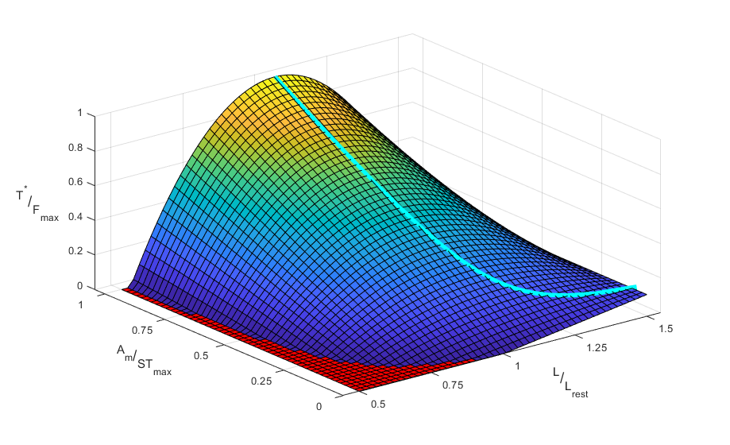

**Figure 6.** A surface representing the steady state tension of a muscle as a function of its length and activation. The red surface represents a tension deadzone, an area of length and activation that is incapable of generating tension despite both values being within valid ranges. The cyan line represents the maximum steady state tension with respect to length.

Tension deadzones are the result of allowing the passive length tension to generate negative values. At moderate values near the resting length, this does not have a large effect. However, when the muscle is significantly below the resting length, it is possible that the “negativity” of the passive tension will counteract the “positivity” of the activation.

To correct tension deadzones, I modified Animatlab using the software developer kit. Specifically, I changed the muscle tension equation to

,

where denotes the ceiling function. This modification fixes the tension deadzone problem.

Physics Timestep Limitations

Another limitation of parameter calculation in Animatlab results from the selection of the physics timestep for the simulation. Due to the numerical analysis used in Animatlab, discrete analysis of the tension equation necessitates limitations on parameter values lest the tension equation become unstable. The discrete representation of the muscle tension is

,

where dt is the physics timestep. At each timestep, the previous tension value is multiplied by a constant value. To prevent asymptotic instability (i.e. oscillations that cause the tension to increase boundlessly), this constant must be bounded. To avoid asymptotic instability, viscoelastic parameters must be bounded such that



is true for all muscle in the system.

Comparison to Experimental Data

The impact of the muscle parameters is examined in comparison to experimental hanging leg experiments.

# Aim 2 – Investigate viscoelastic parameters

Motivation

Muscles act as a transfer function between an organism’s internal control systems and its external environment. Muscles dictate an animal’s posture, its ability to forage or hunt, its ability to breathe. It is clear, then, that the composition of the muscle itself has a huge impact on what kinds of tasks an animal is able to undertake. Viscoelastic properties within muscles are the result of the chemical and structural composition of our actuators.

The interplay of viscoelastic and inertial properties in the limb determine motion. For example, an elephant is capable of “throwing” its leg forward and having it carried forward by its own inertia in order to make its next step. Small animals, whose appendages are proportionally smaller, do not have inertia-dominant walking which makes the viscoelastic properties more important. Therefore, understanding how viscoelastic properties in manifest in small animals could provide insight into the ways that animals regulate their walking patterns across scales.

Recent work has explored the interplay of leg scaling and action speed as it relates to neural control. Small animals have a higher ratio of viscoelastic properties to inertial properties and must activate muscles during swing. Larger animals are able to “throw” their limbs forward using the limb’s inertia, requiring less neural control to move the limb through swing.

This aim presents a series of experimental simulations to characterize the effects of viscoelastic properties in a rat hindlimb.

**Hypothesis 1:** The relative contributions of inertial, damping, and elastic properties of the hindlimb are uniquely suited to respond to perturbations applied to the hindlimb

Developing baseline VE properties for the hindlimb

Viscoelastic properties for the hindlimb are developed by optimizing muscle parameter values in order to match simulation motion to experimental motion. In the Tresch Lab, experiments have been carried out in which rat hindlimbs are allowed to hang freely and individual muscles are stimulated via electrodes. Skin markers are attached to the leg and limb motion is recorded as individual muscles are stimulated at increasing activation levels.

By stimulating the same muscle in simulation, I hope to match the experimental joint angle waveforms generated from the skin marker data.

Paper Idea 1

To explore the interplay of the different aspects of inertial and viscoelatic properties in the rat hindlimb, I propose an experiment in which the leg is cyclically displaced and its perturbation response quantified. I would accomplish this by cyclically pushing on the foot and measuring the limb motion.

# Aim 3 – Investigate muscle activation strategies for hindlimb motion for situations of viscoelastic control.

**Hypothesis 2:** Increasing the scale of the hindlimb (including the scaling of VE parameters) will cause compensatory mechanisms in knee extensors to “turn off” as the organism uses inertial properties to complete the swing phase

Ideas: this is where I can talk about the neural control and design of things

Start out with Canvas and go into NNMF decomposition for synergy control

**Motivation newish**

In order to understand the effect that viscoelastic properties have on neural control, it is necessary to develop a routine for transforming motion into motoneuron activations. This is a multi-step process that requires a combination of sub-routines which decompose the biomechanics into forces and then forces into activations.

First, the model is “driven” through a desired task by placing motors at the joints. Joint motion must be approximated using a sum-of-sines curve fitting process and input as a time-varying equation for the motor. The motor-driven simulation is then used to determine point cloud data for the entire task (attachment point and bone positions for every time step). This information can be used to determine muscle length and moment arm profiles. In addition to gathering point cloud data, passive tension for all muscles is recorded from the motor-driven simulation.

Second, total passive joint torque is calculated by summing together individual passive torque contributions from all muscles acting on a joint. Inertial torques are also included in the model but tend to be relatively small due to the weight of the bone segments. Additionally, it is possible to apply load torques that simulate the effects of ground reaction forces by treating the leg as a multi-segment arm with a force vector at the end effector (Murray, Li, and Sastry 1994).

With joint torques and muscle moment arms calculated, it is possible to distribute muscle forces such that they generate the desired task motion. At each time step, an optimization routine is carried out which calculates muscle forces such that they counteract passive torques and generate task motion. Multiple optimization functions were tested (Pedotti, Krishnan, and Stark 1978; Penrod, Davy, and Singh 1974; Crowninshield and Brand 1981; Kaufman et al. 1991; Prilutsky and Zatsiorsky 2002) to determine which would generate force profiles with minimal switching and saturation.

With force profiles capable of reconstructing task motion, the last step is to convert forces into activation profiles. This involves solving the muscle tension equation for the activation term, Am, and then inverting the stimulus-tension equation (Figure 5B) to find the input voltage. To find an accurate activation, the length and force profiles are combined.

This routine establishes a modular process for converting task motion to motoneuron activation. It is assumed that activation profiles from this process reflect the central nervous system commands which direct motion. Using this process, it is possible to gain insight into how different tasks manifest at a control-system level.

Aim 2 Paper Plan 1

This first paper is a paper that simply explores the VE space for the model and makes the case that considering the VE characteristics is 1) important and 2) has specific ramifications at both control and task level.

Aim 2 Paper Plan 2

# This second paper is more focused on a specific aspect of scaling properties and VE control. Anecdotal evidence from Prilutsky suggests that rats require a burst of activation in the vastus muscles (knee extensors) at the end of swing phase in order to adequately prepare for touch down. In cats, however, this burst doesn’t exist, presumably because the cat uses inertia to swing its leg into position. This would be a case in which scaling effects and VE composition change the way that a control system operates in different animals.

## **Motivation old**

To understand how the nervous system coordinates locomotor activity in the rat, experimental measurements of leg dynamics are converted into motorneuron activation waveforms for each muscle in the hindlimb. Studies of locomotion and postural control have shown that motorneuron activation can be organized into functional groups commonly referred to as muscle synergies or modules (W. A. Lee 1984; d’Avella, Saltiel, and Bizzi 2003; Ting and Macpherson 2005; Tresch, Cheung, and d’Avella 2006). Understanding the role that synergies play in coordinating groups of muscles could provide insight into the spinal circuitry that underlies walking or serve as a novel method of robotic control.

Muscle synergies represent a form of nervous-to-body-system interface where the state of the external environment dictates the functional capabilities of the nervous system through its manifestation in the body. The division of the nervous system into organized groups reduces the complexity of the control system necessary to coordinate locomotion. Recent studies indicate that muscle synergies may not have a physical manifestation in the nervous system and are instead a statistical artifact that arises from the body meeting task-specific demands (Perreault et al. 2008; Tresch and Jarc 2009; Kutch and Valero-Cuevas 2011). Incorporating synergistic components with well-established CPG driven locomotion could suggest novel connections between the nervous system and the body.

By developing a nervous system to control the multi-muscle kinematic model described in Aim 1, it is possible to investigate different structural arrangements best-suited for controlled locomotion under nominal and perturbed conditions.

## Completed Work: Passive Torque

To calculate torque generation during locomotion specifically produced by muscles, it is necessary to subtract the activity of passive torque. Passive torque stems from two sources: passive elastic properties of muscles and the weight of the animal. Figure 7 shows the total passive torque and the individual contributions of the load torque and muscle torque.

Passive elastic muscle force is only generated when the muscle length is extended beyond the resting muscle length. I calculate passive elastic force by evaluating the Hill equation without stimulus. Torque generated by passive elastic muscle force is the passive muscle force multiplied by the muscle moment arm at each time step during stride. This value is summed for all muscles about a specific joint.

Passive joint torque also manifests from the body weight of the animal pushing down on the hip joint during walking. I calculated this value by treating the leg as a multi-segment arm and using the ground reaction forces (GRFs) to calculate the induced joint torque. Passive torque from body weight was calculated by computing the spatial manipulator Jacobian, an operator for converting end effector forces into torques at the joints (Murray, Li, and Sastry 1994). GRFs were generated from the three dimensional data from Muir et al. (Muir and Whishaw 1999).

## Completed Work: Implemented Multiple Optimization Functions

To distribute the total torque profile between individual muscle contributions, I implemented multiple optimization criteria. Force optimization is a common method of addressing the infinite possible solutions that exist for force generation of the over actuated muscle system. Most methods distribute forces based on a physiological metric, such as muscle length or cross section.

Previous approaches minimize cumulative muscle parameters such as force (Pedotti, Krishnan, and Stark 1978; Penrod, Davy, and Singh 1974), stress (Crowninshield and Brand 1981), activation (Kaufman et al. 1991), and fatigue (Prilutsky and Zatsiorsky 2002). These optimization methods have been applied to force sharing in cat hindlimbs but, although some cost functions are better in certain situations, none of the aforementioned methods perfectly recreate experimental results (Herzog and Leonard 1991). The development of an optimization method that perfectly recreates experimentally recorded data is an ongoing research topic.

Initially, I minimized the summed muscle forces at each time step during a single stride using linear optimization. While it is true that the torque profile is comprised of a linear combination of muscle torques (i.e. ), linear optimization solutions fall on what Crowninshield et al. refers to as an “optimization corner” of the solution space. Optimization corners cause jagged force profiles, shown in Figure 8, that are not indicative of actual muscle contractions. The failure of this method to produce viable force profiles demanded a nonlinear optimization equation instead.

I have evaluated force distribution results from multiple cost functions from Pedotti et al. and Seireg et al. (Seireg and Arvikar 1973), including linear and nonlinear cost functions. The results of this analysis are shown in Figure 8, with the most suitable cost function appearing to be the fourth cost function from Pedotti et al., which relates muscle forces to their maximum values squared.

## Aim 2 Proposed Work: Analyzing How the Hill Parameter Space Affects Force Decomposition and EMG Modeling

A number of musculoskeletal models use Hill muscles but few discuss parameter calculations, underlying assumptions, or whether the model matches experimental data for individual muscles. Using muscle force or EMG data from research partners, it would be possible to make the model more biologically representative by optimizing muscle parameters. A publication that explores how varying the Hill parameter space impacts the optimized force distribution could identify parameters that are more important for neuromechanical modeling.

Additionally, modeled EMG signals can be compared to muscle recordings gathered by research collaborators. To find the neural stimulation necessary to induce the optimized force profiles, the ST equation can be solved for motorneuron voltage. Varying Hill parameters could provide insight into which muscular properties have the biggest impact on EMG signals.

## Aim 2 Proposed Work: Neural Control Based on Synergy Decomposition of Modeled EMGs

Statistical methods are used to decompose aggregate electromyography (EMG) measurements from many muscles into synergies. Multiple matrix factorization techniques have been used to characterize synergy profiles (Tresch, Cheung, and d’Avella 2006; Torres-Oviedo and Ting 2007; Taborri et al. 2018), with the most common being nonnegative matrix factorization (NNMF) (D. D. Lee and Seung 2001; Berry et al. 2007; Ting et al. 2012). In NNMF, rectified, low-pass filtered EMG recordings are decomposed into a set of spatial vectors, representing time invariant muscle activation profiles, and temporal vectors, representing the timing of synergy coactivation. These vectors can then be compared across subjects or a variety of tasks to identify recurring features that may suggest the underlying neural basis for specific synergy profiles.

I have already applied NNMF algorithms to the raw force data, as shown in Figure 9. This algorithm has been tested on the force data first because EMG data has not been derived from the force waveforms yet. The process for NNMF will be identical when the input is EMG data. The number of synergies is commonly determined by meeting a Pearson correlation value between the recombined signal and the original signal. For this work, the synergy number was set to 5 for simplicity.

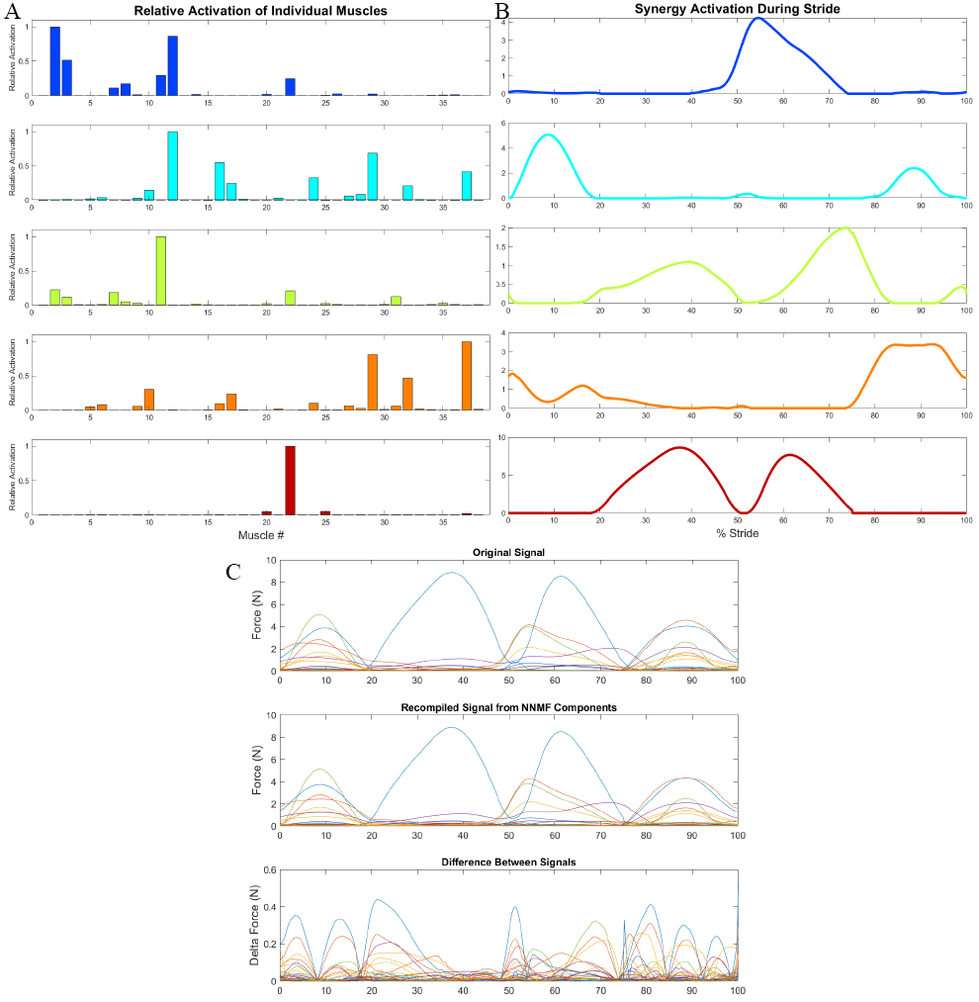

**Figure 9** NNMF Applied to optimized force data from the multi-muscle hindlimb model. A) Time-invariant, relative activation of individual muscles within five synergies. B) Magnitude of synergy activation during stride. C) The original input signal and the signal generated by recombining the synergy components derived by the NNMF process. The difference between the signals is shown in the third panel.

Using the data from the NNMF decomposition, it is possible to integrate the synergy profiles as groups of synaptic connections from a single “synergy” neuron that is driven by upstream CPGs. Further work needs to be done to identify specific neural topology capable of coordinating locomotion using this technique. The integration of biarticular muscle (muscles that span more than one joint) control has been explored in the context of Hunt’s model but not et implemented into the full-muscle model (Deng et al. 2019).

One possibility for this integration is through a design process for the creation of large-scale, stable models of the nervous system using modular components called functional subnetworks (FSNs) with known input-output relationships (Szczecinski, Hunt, and Quinn 2017). The implementation of a nervous system using the FSN approach allows for modular expansion of a system as new biological systems are discovered. The focus on functional relationships also makes the FSN a useful tool for robotic control networks, as has been shown in a robot modeled after a praying mantis (Szczecinski et al. 2017).

## Aim 2 Proposed Work: Investigating the Impact of Perturbed vs. Nominal Environments on EMG Signal Generation

Stimuli in the form of environmental perturbations (irregular ground conditions, obstacles, etc.) that are implemented in experimental protocols cause changes in locomotion that suggest novel reflexive connections in the nervous system. Sensory feedback systems modulate reflexes in the absence of cognitive activity, providing an unbiased glimpse into the activity of locomotion pathways. Implementing perturbations in simulation would allow for the comparison of experimental data and provide insight into necessary modifications of nervous systems designed for nominal locomotion.

## **Supplementary Material**

Viscoelastic Parameter Optimization

For a single muscle, tension is developed according to the equation,

.

where T is muscle tension, Kse is series element stiffness, B is damping, L is muscle length, Lrest is muscle resting length, Al is the length-tension factor, and Am is the stimulus-tension (ST) force. The  symbol represents the ceiling function.

The goal of this work is to develop baseline viscoelastic (VE) parameters for the hindlimb muscles by matching passive and active experimental joint motion. This is accomplished by optimizing the parameters Kse, Kpe, and B for thirty-eight muscles to reduce the sum-squared difference between joint motion from simulation and experimental hanging leg experiments. This results in an optimization input vector with 3x38 terms.

In addition to matching experimental results by tuning the VE parameters, it is important that the results provide a functional basis for simulations in Animatlab. For a maximal (20 nA) stimulus, I want the muscle to be capable of generating its maximum tension (Fmax) while at steady state. When not stimulated (0 nA), I want the muscle tension to be purely passive (Am = 0).

Model values for maximal tension, Fmax, are taken from the literature (Johnson et al. 2011) while Lrest values are provided by the model directly. The model is moved through its full range of motion to determine Lmin and Lmax for each muscle. Lrest is set as the halfway point between these two values. The muscle width, Lw, is set such that the muscle can generate 70% of its maximal tension when at Lmin or Lmax­.

The optimizer for this process is the patternsearch function in Matlab. This process perturbs input values in a “mesh” pattern in order to find parameter combinations that reduce a cost function. Patternsearch is useful for problems that do not have a defined gradient, such as a simulation with discrete outputs. In addition to using the mesh polling method, a mesh adaptive direct search is included to increase effectiveness by performing an additional search step before polling for new values.

Linear constraints are applied to the optimizer to ensure that the tension profiles in Animatlab do not become asymptotically unstable. This limitation, related to the size of the physics timestep, dt, is described in detail in a 2020 Living Machines paper. These linear constraints ensure that the physics timestep constraint,

,

is true for all muscles.

ST Parameter Derivation

The activation parameter, Am, represents a sigmoidal relationship between stimulus and tension which is important for controlling muscles by applying voltage to the motoneuron. Specifically, the maximum value of Am (STmax) and the steepness of the ST slope have the largest impact on the relationship between stimulus and tension. The stimulus-tension equation takes the form

,

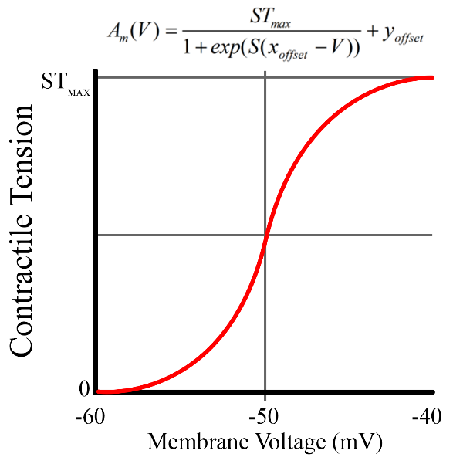where S is steepness, xoff is the voltage offset (set to -50mV for all muscles), V is the motoneuron voltage, and yoff is the output offset. The range for the ST curve is defined as [-60, 40] mV in order to interface with functional subnetwork neurons defined from prior work (Szczecinski, Hunt, and Quinn 2017).

**Figure 1** The basic ST curve shape and equation.

Originally, I set the ST output range to [0, 1.05Fmax] and then determined the necessary stiffness for each muscle. The motivation for this method was to establish a range in which STmax was slightly larger than Fmax with the belief that the Am parameter would then be able to generate all values up to the maximum tension. However, these values required a curve steepness that was quite large (~1200), resulting in a steep curve with a form similar to that in Figure 2.

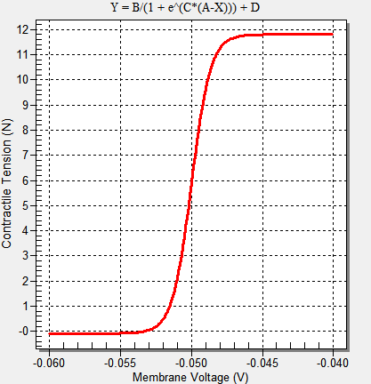

**Figure 2** A steeper ST curve causes the muscle to behave like a switch.

The issues with a steep ST curve using the output values as defined above are twofold. First, the tension generating capabilities of motoneuron stimulation are inhibited by a term in the tension equation which reduces the output range of the ST curve. Second, the steeper the ST curve is, the more it behaves like a switch.

When running experiments where the hindlimb is actuated by muscle stimulation, I noticed that the maximum tension for any muscle was much smaller than Fmax. This limited the tension output and made the leg weaker than it could be. The reduced output is related to the term  in the tension equation. Essentially, this term inhibits tension generation, while Am is trying to increase it. To address this issue, the value of STmax is dynamically set based on the viscoelastic parameters of the muscle in order to balance the inhibitory tension term with the activation term.

To accomplish this, the value is set such that

.

This assumes that at steady-state resting position, the muscle can generate Fmax by stimulating the motoneuron. This approach can create values of STmax that are dramatically larger than Fmax, exacerbating the switch-like behavior related to curve steepness.

It is difficult to create smooth motoneuron-driven motion with a steep curve because muscle tension tends to switch on and off rather than gradually shift values during stride. To address this issue, I decided to set the curve steepness to a specific value for all muscles such that the switch-like behavior is reduced. To accomplish this, I reduced the ST curve output range slightly to [0, .98STmax]. To find the necessary steepness for this range, we solve equations at the end values.





which results in values of  and .

Now, when I set Kse, Kpe, and B for each muscle, I also set ,, and S = 459.5.

## References

Avella, Andrea d’, Philippe Saltiel, and Emilio Bizzi. 2003. “Combinations of Muscle Synergies in the Construction of a Natural Motor Behavior.” *Nature Neuroscience* 6 (3): 300–308. https://doi.org/10.1038/nn1010.

Beer, Randall D., Hillel J. Chiel, and John C. Gallagher. 1999. “Evolution and Analysis of Model CPGs for Walking: II. General Principles and Individual Variability.” *Journal of Computational Neuroscience* 7 (2): 119–47. https://doi.org/10.1023/A:1008920021246.

Beer, Randall D., Roger D. Quinn, Hillel J. Chiel, and Roy E. Ritzmann. 1997. “Biologically Inspired Approaches to Robotics: What Can We Learn from Insects?” *Commun. ACM* 40 (3): 30–38. https://doi.org/10.1145/245108.245118.

Berry, Michael W., Murray Browne, Amy N. Langville, V. Paul Pauca, and Robert J. Plemmons. 2007. “Algorithms and Applications for Approximate Nonnegative Matrix Factorization.” *Computational Statistics & Data Analysis* 52 (1): 155–73. https://doi.org/10.1016/j.csda.2006.11.006.

Chang, Sarah R., Mark J. Nandor, Lu Li, Rudi Kobetic, Kevin M. Foglyano, John R. Schnellenberger, Musa L. Audu, Gilles Pinault, Roger D. Quinn, and Ronald J. Triolo. 2017. “A Muscle-Driven Approach to Restore Stepping with an Exoskeleton for Individuals with Paraplegia.” *Journal of NeuroEngineering and Rehabilitation* 14 (1): 48. https://doi.org/10.1186/s12984-017-0258-6.

Charles, James P., Ornella Cappellari, Andrew J. Spence, Dominic J. Wells, and John R. Hutchinson. 2016. “Muscle Moment Arms and Sensitivity Analysis of a Mouse Hindlimb Musculoskeletal Model.” *Journal of Anatomy* 229 (4): 514–35. https://doi.org/10.1111/joa.12461.

Chiel, Hillel J., and Randall D. Beer. 1997. “The Brain Has a Body: Adaptive Behavior Emerges from Interactions of Nervous System, Body and Environment.” *Trends in Neurosciences* 20 (12): 553–57. https://doi.org/10.1016/S0166-2236(97)01149-1.

Chiel, Hillel J., Randall D. Beer, and Leon S. Sterling. 1988. “Heterogeneous Neural Networks for Adaptive Behavior in Dynamic Environments.” In *Proceedings of the 1st International Conference on Neural Information Processing Systems*, 577–585. NIPS’88. Cambridge, MA, USA: MIT Press. http://dl.acm.org/citation.cfm?id=2969735.2969802.

Chiel, Hillel J., Lena H. Ting, Örjan Ekeberg, and Mitra J. Z. Hartmann. 2009. “The Brain in Its Body: Motor Control and Sensing in a Biomechanical Context.” *Journal of Neuroscience* 29 (41): 12807–14. https://doi.org/10.1523/JNEUROSCI.3338-09.2009.

Crowninshield, Roy D., and Richard A. Brand. 1981. “A Physiologically Based Criterion of Muscle Force Prediction in Locomotion.” *Journal of Biomechanics* 14 (11): 793–801. https://doi.org/10.1016/0021-9290(81)90035-X.

Deng, Kaiyu, Nicholas S. Szczecinski, Dirk Arnold, Emanuel Andrada, Martin S. Fischer, Roger D. Quinn, and Alexander J. Hunt. 2019. “Neuromechanical Model of Rat Hindlimb Walking with Two-Layer CPGs.” *Biomimetics* 4 (1): 21. https://doi.org/10.3390/biomimetics4010021.

Eng, Carolyn M., Laura H. Smallwood, Maria Pia Rainiero, Michele Lahey, Samuel R. Ward, and Richard L. Lieber. 2008. “Scaling of Muscle Architecture and Fiber Types in the Rat Hindlimb.” *Journal of Experimental Biology* 211 (14): 2336–45. https://doi.org/10.1242/jeb.017640.

Greene, E. C. 1955. *Anatomy of the Rat.* New York: Hafner Publishing Co. https://www.cabdirect.org/cabdirect/abstract/19561405416.

Herzog, W., and T. R. Leonard. 1991. “Validation of Optimization Models That Estimate the Forces Exerted by Synergistic Muscles.” *Journal of Biomechanics*, Proceedings of the NASA Symposium on the Influence of Gravity and Activity on Muscle and Bone, 24 (January): 31–39. https://doi.org/10.1016/0021-9290(91)90375-W.

Hill Archibald Vivian. 1938. “The Heat of Shortening and the Dynamic Constants of Muscle.” *Proceedings of the Royal Society of London. Series B - Biological Sciences* 126 (843): 136–95. https://doi.org/10.1098/rspb.1938.0050.

Hunt, Alexander. 2016. “Neurologically Based Control for Quadruped Walking.” Cleveland, OH: Case Western Reserve University.

Hunt, Alexander, Manuela Schmidt, Martin Fischer, and Roger D. Quinn. 2014. “Neuromechanical Simulation of an Inter-Leg Controller for Tetrapod Coordination.” In *Biomimetic and Biohybrid Systems*, edited by Armin Duff, Nathan F. Lepora, Anna Mura, Tony J. Prescott, and Paul F. M. J. Verschure, 142–53. Lecture Notes in Computer Science. Springer International Publishing.

Hunt, Alexander, Nicholas Szczecinski, and Roger Quinn. 2017. “Development and Training of a Neural Controller for Hind Leg Walking in a Dog Robot.” *Frontiers in Neurorobotics* 11. https://doi.org/10.3389/fnbot.2017.00018.

Hunt, Alexander, Nicholas S. Szczecinski, Emanuel Andrada, Martin Fischer, and Roger D. Quinn. 2015. “Using Animal Data and Neural Dynamics to Reverse Engineer a Neuromechanical Rat Model.” In *Biomimetic and Biohybrid Systems*, edited by Stuart P. Wilson, Paul F.M.J. Verschure, Anna Mura, and Tony J. Prescott, 211–22. Lecture Notes in Computer Science. Springer International Publishing.

Johnson, W. L., D. L. Jindrich, H. Zhong, R. R. Roy, and V. R. Edgerton. 2011. “Application of a Rat Hindlimb Model: A Prediction of Force Spaces Reachable Through Stimulation of Nerve Fascicles.” *IEEE Transactions on Biomedical Engineering* 58 (12): 3328–38. https://doi.org/10.1109/TBME.2011.2106784.

Kaufman, K. R., K. -N. An, W. J. Litchy, and E. Y. S. Chao. 1991. “Physiological Prediction of Muscle Forces—I. Theoretical Formulation.” *Neuroscience* 40 (3): 781–92. https://doi.org/10.1016/0306-4522(91)90012-D.

Kutch, Jason J., and Francisco J. Valero-Cuevas. 2011. “Muscle Redundancy Does Not Imply Robustness to Muscle Dysfunction.” *Journal of Biomechanics* 44 (7): 1264–70. https://doi.org/10.1016/j.jbiomech.2011.02.014.

Lakatos, D., A. Albu-Schäffer, C. Rode, and F. Loeffl. 2016. “Dynamic Bipedal Walking by Controlling Only the Equilibrium of Intrinsic Elasticities.” In *2016 IEEE-RAS 16th International Conference on Humanoid Robots (Humanoids)*, 1282–89. https://doi.org/10.1109/HUMANOIDS.2016.7803435.

Lee, Daniel D., and H. Sebastian Seung. 2001. “Algorithms for Non-Negative Matrix Factorization.” In *Advances in Neural Information Processing Systems 13*, edited by T. K. Leen, T. G. Dietterich, and V. Tresp, 556–562. MIT Press. http://papers.nips.cc/paper/1861-algorithms-for-non-negative-matrix-factorization.pdf.

Lee, Sang Wook, Hua Chen, Joseph D. Towles, and Derek G. Kamper. 2008. “Estimation of the Effective Static Moment Arms of the Tendons in the Index Finger Extensor Mechanism.” *Journal of Biomechanics* 41 (7): 1567–73. https://doi.org/10.1016/j.jbiomech.2008.02.008.

Lee, Wynne A. 1984. “Neuromotor Synergies as a Basis for Coordinated Intentional Action.” *Journal of Motor Behavior* 16 (2): 135–70. https://doi.org/10.1080/00222895.1984.10735316.

McCrea, David A., and Ilya A. Rybak. 2008. “Organization of Mammalian Locomotor Rhythm and Pattern Generation.” *Brain Research Reviews*, Networks in Motion, 57 (1): 134–46. https://doi.org/10.1016/j.brainresrev.2007.08.006.

Muir, G. D., and Ian Q. Whishaw. 1999. “Ground Reaction Forces in Locomoting Hemi-Parkinsonian Rats: A Definitive Test for Impairments and Compensations.” *Experimental Brain Research* 126 (3): 307–14. https://doi.org/10.1007/s002210050739.

Murray, Richard M., Zexiang Li, and S. Shankar Sastry. 1994. *A Mathematical Introduction to Robotic Manipulation*. CRC Press.

Nishikawa, Kiisa, Andrew A. Biewener, Peter Aerts, Anna N. Ahn, Hillel J. Chiel, Monica A. Daley, Thomas L. Daniel, et al. 2007. “Neuromechanics: An Integrative Approach for Understanding Motor Control.” *Integrative and Comparative Biology* 47 (1): 16–54. https://doi.org/10.1093/icb/icm024.

Pedotti, A., V. V. Krishnan, and L. Stark. 1978. “Optimization of Muscle-Force Sequencing in Human Locomotion.” *Mathematical Biosciences* 38 (1): 57–76. https://doi.org/10.1016/0025-5564(78)90018-4.

Penrod, D.D., D.T. Davy, and D.P. Singh. 1974. “An Optimization Approach to Tendon Force Analysis.” *Journal of Biomechanics* 7 (2): 123–29. https://doi.org/10.1016/0021-9290(74)90050-5.

Perreault, Eric J., Kuifu Chen, Randy D. Trumbower, and Gwyn Lewis. 2008. “Interactions With Compliant Loads Alter Stretch Reflex Gains But Not Intermuscular Coordination.” *Journal of Neurophysiology* 99 (5): 2101–13. https://doi.org/10.1152/jn.01094.2007.

Pfeifer, Rolf, Max Lungarella, and Fumiya Iida. 2007. “Self-Organization, Embodiment, and Biologically Inspired Robotics.” *Science* 318 (5853): 1088–93. https://doi.org/10.1126/science.1145803.

Prilutsky, Boris I., and Vladimir M. Zatsiorsky. 2002. “Optimization-Based Models of Muscle Coordination.” *Exercise and Sport Sciences Reviews* 30 (1): 32.

Schrade, Stefan O., Katrin Dätwyler, Marius Stücheli, Kathrin Studer, Daniel-Alexander Türk, Mirko Meboldt, Roger Gassert, and Olivier Lambercy. 2018. “Development of VariLeg, an Exoskeleton with Variable Stiffness Actuation: First Results and User Evaluation from the CYBATHLON 2016.” *Journal of NeuroEngineering and Rehabilitation* 15 (1): 18. https://doi.org/10.1186/s12984-018-0360-4.

Seireg, A., and R.J. Arvikar. 1973. “A Mathematical Model for Evaluation of Forces in Lower Extremeties of the Musculo-Skeletal System.” *Journal of Biomechanics* 6 (3): 313–26. https://doi.org/10.1016/0021-9290(73)90053-5.

Shadmehr, Reza, and Michael A. Arbib. 1992. “A Mathematical Analysis of the Force-Stiffness Characteristics of Muscles in Control of a Single Joint System.” *Biological Cybernetics* 66 (6): 463–77. https://doi.org/10.1007/BF00204111.

Sharbafi, Maziar Ahmad, Christian Rode, Stefan Kurowski, Dorian Scholz, Rico Möckel, Katayon Radkhah, Guoping Zhao, Aida Mohammadinejad Rashty, Oskar von Stryk, and Andre Seyfarth. 2016. “A New Biarticular Actuator Design Facilitates Control of Leg Function in BioBiped3.” *Bioinspiration & Biomimetics* 11 (4): 046003. https://doi.org/10.1088/1748-3190/11/4/046003.

Szczecinski, Nicholas S., Andrew P. Getsy, Joshua P. Martin, Roy E. Ritzmann, and Roger D. Quinn. 2017. “Mantisbot Is a Robotic Model of Visually Guided Motion in the Praying Mantis.” *Arthropod Structure & Development*, From Insects to Robots, 46 (5): 736–51. https://doi.org/10.1016/j.asd.2017.03.001.

Szczecinski, Nicholas S., Alexander J. Hunt, and Roger D. Quinn. 2017. “A Functional Subnetwork Approach to Designing Synthetic Nervous Systems That Control Legged Robot Locomotion.” *Frontiers in Neurorobotics* 11. https://doi.org/10.3389/fnbot.2017.00037.

Taborri, Juri, Valentina Agostini, Panagiotis K. Artemiadis, Marco Ghislieri, Daniel A. Jacobs, Jinsook Roh, and Stefano Rossi. 2018. “Feasibility of Muscle Synergy Outcomes in Clinics, Robotics, and Sports: A Systematic Review.” Research article. Applied Bionics and Biomechanics. 2018. https://doi.org/10.1155/2018/3934698.

Ting, Lena H., Stacie A. Chvatal, Seyed A. Safavynia, and J. Lucas McKay. 2012. “Review and Perspective: Neuromechanical Considerations for Predicting Muscle Activation Patterns for Movement.” *International Journal for Numerical Methods in Biomedical Engineering* 28 (10): 1003–14. https://doi.org/10.1002/cnm.2485.

Ting, Lena H., and Jane M. Macpherson. 2005. “A Limited Set of Muscle Synergies for Force Control During a Postural Task.” *Journal of Neurophysiology* 93 (1): 609–13. https://doi.org/10.1152/jn.00681.2004.

Torres-Oviedo, Gelsy, and Lena H. Ting. 2007. “Muscle Synergies Characterizing Human Postural Responses.” *Journal of Neurophysiology* 98 (4): 2144–56. https://doi.org/10.1152/jn.01360.2006.

Tresch, Matthew C., Vincent C. K. Cheung, and Andrea d’Avella. 2006. “Matrix Factorization Algorithms for the Identification of Muscle Synergies: Evaluation on Simulated and Experimental Data Sets.” *Journal of Neurophysiology* 95 (4): 2199–2212. https://doi.org/10.1152/jn.00222.2005.

Tresch, Matthew C, and Anthony Jarc. 2009. “The Case for and against Muscle Synergies.” *Current Opinion in Neurobiology*, Motor systems • Neurology of behaviour, 19 (6): 601–7. https://doi.org/10.1016/j.conb.2009.09.002.

Visser, J. J., J. E. Hoogkamer, M. F. Bobbert, and P. A. Huijing. 1990. “Length and Moment Arm of Human Leg Muscles as a Function of Knee and Hip-Joint Angles.” *European Journal of Applied Physiology and Occupational Physiology* 61 (5): 453–60. https://doi.org/10.1007/BF00236067.

Webster-Wood, Victoria A., Ozan Akkus, Umut A. Gurkan, Hillel J. Chiel, and Roger D. Quinn. 2017. “Organismal Engineering: Toward a Robotic Taxonomic Key for Devices Using Organic Materials.” *Science Robotics* 2 (12). https://doi.org/10.1126/scirobotics.aap9281.

Williams, S. B., A. M. Wilson, L. Rhodes, J. Andrews, and R. C. Payne. 2008. “Functional Anatomy and Muscle Moment Arms of the Pelvic Limb of an Elite Sprinting Athlete: The Racing Greyhound (Canis Familiaris).” *Journal of Anatomy* 213 (4): 361–72. https://doi.org/10.1111/j.1469-7580.2008.00961.x.

Yeo, Sang Hoon, Christopher H. Mullens, Thomas G. Sandercock, Dinesh K. Pai, and Matthew C. Tresch. 2011. “Estimation of Musculoskeletal Models from in Situ Measurements of Muscle Action in the Rat Hindlimb.” *Journal of Experimental Biology* 214 (5): 735–46. https://doi.org/10.1242/jeb.049163.

Young, Fletcher, Christian Rode, Alex Hunt, and Roger Quinn. 2019. “Analyzing Moment Arm Profiles in a Full-Muscle Rat Hindlimb Model.” *Biomimetics* 4 (1): 10. https://doi.org/10.3390/biomimetics4010010.

Zajac, F. E. 1989. “Muscle and Tendon: Properties, Models, Scaling, and Application to Biomechanics and Motor Control.” *Critical Reviews in Biomedical Engineering* 17 (4): 359–411.